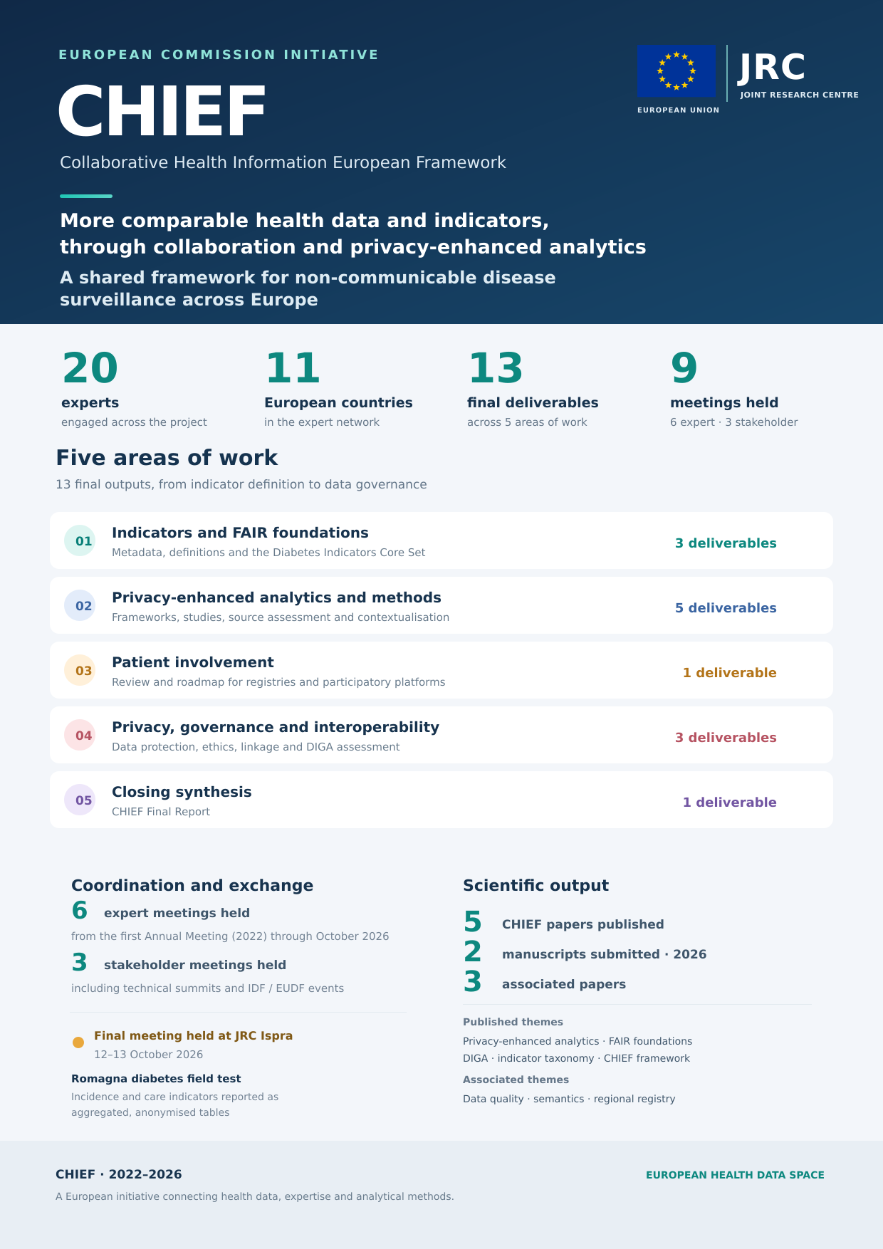
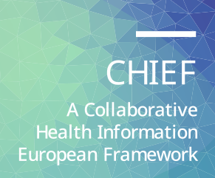

A European Commission initiative:
Collaborative Health Information European Framework (CHIEF)
FINAL PRODUCTS

Table 1. List of reports
# | Activity | Deliverable (authors) | Version | Deadline
1 | 1 | Metadata - definition, semantic description, and FAIR-ification. F Carinci S Cunningham, S Fava, N Klazinga, A Lavens, J Lepiksone, M Massi Benedetti, T Poljičanin, P Rossing, J Sándor, I Štotl | Final  (v. 1.0) | 18/2/2025
2 | 1 | Indicator framework. Diabetes Indicators Core Set. F Carinci, S Cunningham, S Fava, N Klazinga, A Lavens, J Lepiksone, M Massi Benedetti, T Poljičanin, P Rossing, I Štotl | Final (v.5.1.3) | 6/4/2025
3 | 1 | Technical report specifying the description,  metadata and contextualisation of indicators from data sources and registries to enable routine federated reporting of NCDs in Europe. F Carinci, S Cunningham, J Dimnjaković, S Fava, T Poljičanin, I Štotl | Final (v.1.0) | 25/9/2026
4 | 2 | Use of federated software to measure the impact  of risk factors and data quality for cardiovascular risk prediction among people with diabetes, using cohorts extracted from federated diabetes registers in Europe. F Carinci, S Cunningham, I Stotl, Z Baltane, S Fava | Final (v.1.1) | 17/9/2024
5 | 2 | Operational plan to build a coherent EU Information System for NCDs: design of targeted studies for the timely reporting of NCD indicators in the European Health Data Space. F Carinci, I Stotl | Final  (v. 1.1) | 11/3/2025
6 | 2 | Updated method to carry out automated reviews of data sources and registers across NCDs in EU countries: an application on needs and gaps for CVD risk stratification in diabetes. F Carinci, S Fava, I Stotl | Final  (v. 0.5) | 17/4/2025
7 | 2 | A proposal for a federated data analysis framework with practical examples provided of specific indicators S Fava, F Carinci | Final  (v. 0.3) | 28/4/2025
8 | 2 | Integration of federated analytics with metadata contextualisation in a multidisciplinary collaborative framework for the routine reporting of NCD indicators in Europe. F Carinci, P Di Bartolo, I Štotl, S Fava, S Cunningham, L Pennells, Z Baltane, S Reiff, T Poljičanin, J Dimnjakovic | Final  (v 1.0) | 25/9/2026
9 | 3 | Patient involvement in chronic disease registries. M Massi Benedetti, E Dupont, C Michael, F Carinci, S Cunningham, J Dimnjakovich, T Poljicanin, I Stotl, N Nicholson | Final  (v 1.0) | 22/6/2026
10 | 4 | Privacy, data governance and ethics in the handling of sensitive data: assessment of current practices in the field of diabetes. CT Di Iorio, E Ronchi, I Pristas, T Buble | Final  (v. 4.0) | 15/3/2025
11 | 4 | Data Linkage & Interoperability. C T Di Iorio, E Ronchi, I Pristas, T Buble | Final | 20/7/2024
12 | 4 | Monitoring privacy, data protection, data governance, interoperability and ethics in registries and health information systems to balance compliance with the accurate reporting of NCD indicators CT Di Iorio, E Ronchi, F Carinci, I Štotl, I Pristas, T Buble | Final  (v. 5.0) | 15/7/2026
13 | 5 | CHIEF Final report | Final  (v. 2.3) | 7/10/2026

PAPERS
Submitted
- Di Iorio CT, Carinci F, Štotl I, Pristas I, Buble T, Nicholson N, Ronchi E. How ready are data holders for the European Health Data Space? Results of an international survey using a refined version of Data Protection, Interoperability and Data Governance Assessment (DIGA), Submitted, 2026.
- Massi-Benedetti M, Michael CM, Carinci F, Cunningham S, Dimnjakovic J, Poljicanin T, Štotl I, Nicholson N and Dupont E, Patient involvement in chronic disease registries: a narrative review and roadmap for the implementation of participative European data platforms, Submitted, 2026.
Published
- Carinci F, Fava S, Štotl I, Nicholson N. Federated analytics for non-communicable disease surveillance in the European health data space: a scoping review and conceptual framework. Front Public Health. 2026 Aug 21;14:1911992. Available at: https://pmc.ncbi.nlm.nih.gov/articles/PMC13543158/.
- Štotl I, Carinci F, Fava S, Lavens A, Lepiksone J, Massi-Benedetti M, Poljičanin T, Cunningham S, Sándor J , Nicholson N, FAIR Foundations of a Novel Indicator Vault for Non-communicable Diseases in the European Union: Feasibility Study for Effective Contextualization of Indicators, Front. Digit. Health, 16 December 2025. Available at: https://www.frontiersin.org/journals/digital-health/articles/10.3389/fdgth.2025.1685733/full.
- Carinci F., Nicholson N, Linking registries to deliver standardised NCD indicators in the European Health Data Space: why do we need a Collaborative Health Information European Framework, Front. Public Health, 03 November 2025. Available at: https://www.frontiersin.org/journals/public-health/articles/10.3389/fpubh.2025.1684947/full.
- Di Iorio CT, Ronchi E, Pristas I, Buble T, Nicholson N, Carinci F, Data Protection, Interoperability and Governance Assessment (DIGA) Tool: results from a proof-of-concept survey, Front. Digit. Health, 27 October 2025, Volume 7, 2025. Available at: https://www.frontiersin.org/journals/digital-health/articles/10.3389/fdgth.2025.1685774/full
- Carinci F, Poljičanin T, Cunningham S, Fava S, Štotl I, Lepiksone J, Nicholson N, Massi Benedetti M and Klazinga N, A taxonomy of indicators for Non-Communicable Diseases: agreement, definition, and contextual description using diabetes as a case study, Front. Public Health, 13 October 2025, Volume 13, 2025. Available at: https://www.frontiersin.org/journals/public-health/articles/10.3389/fpubh.2025.1685731/full.

ASSOCIATED PAPERS
- Nicholson N, Carvalho R, Stotl I, A FAIR perspective on data quality frameworks, Data, 10, 9, 2025, p. 136, MDPI AG. Available at: https://data.europa.eu/doi/10.3390/data10090136.
- Nicholson N, Stotl I, A Generic Framework for the Semantic Contextualisation of Indicators, Frontiers in Computer Science, ISSN 2624-9898, 6, 2024. Available at: https://www.frontiersin.org/journals/computer-science/articles/10.3389/fcomp.2024.1463989/full.
- Carinci F, Messina R, Mencarelli M, Michelini MM, Bici A, Berardo A, Cas AD, Iezzi E, Aldigeri R, Di Iorio CT, Gualdi S, Fantini MP, Bonadonna R, Nicholson N, Benedetti MM, Di Bartolo P. Implementing a federated regional diabetes register in a decentralized health system: implications for healthcare organization and the European Health Data Space. Front Public Health. 2026 Jul 16;14:1864673. Available at: https://www.frontiersin.org/journals/public-health/articles/10.3389/fpubh.2026.1864673/full.
FIELD TEST ANALYTICS
- Collaborative agreement CHIEF-AUSL Romagna, Italy. Service contract “CHIEF DATA COLLECTION FIELD TEST”. Provision of a set of indicators describing aspects of diabetes incidence and care in the Romagna region, delivered in the form of tables containing aggregated and anonymized data, in compliance with applicable data protection regulations.

Table 2. List of experts involved by country
# | Country | Expert
1 | Belgium | Elisabeth Dupont
2 | Belgium | Astrid Lavens
3 | Croatia | Tamara Buble
4 | Croatia | Jelena Dimnjakovic
5 | Croatia | Tamara Poljicanin
6 | Croatia | Ivan Pristaš
7 | Denmark | Peter Rossing
8 | France | Elettra Ronchi
9 | Hungary | Janos Sandor
10 | Italy | Fabrizio Carinci
11 | Italy | Tania Di Iorio
12 | Italy | Massimo Massi Benedetti
13 | Latvia | Zane Baltāne
14 | Latvia | Jana Lepiksone
15 | Malta | Stephen Fava
16 | Malta | Sascha Reiff
17 | Netherlands | Niek Klazinga
18 | Slovenia | Iztok Stotl
19 | United Kingdom | Scott Cunningham
20 | United Kingdom | Lisa Pennells

Table 3. Expert Meetings
# | Year | Meeting | Date
1 | 2022 | 1st Annual Meeting | 4/11/2022
2 | 2022 | IDF Lisbon Conference Meeting | 8/12/2022
3 | 2024 | 2nd Annual Meeting, JRC Ispra | 25/10/2024
4 | 2025 | 3rd Annual Meeting, JRC Ispra | 19/12/2025
5 | 2026 | 4th Annual Meeting, JRC Ispra | 3/7/2026
6 | 2026 | Final Meeting, JRC Ispra | 12-13/10/2026

Table 4. Stakeholder Meetings
# | Year | Meeting | Date
1 | 2023 | IDF Europe Regional Council & TEAM WHO Europe-IDF Europe High-Level Technical Summit  on Diabetes | 28/11/2023
2 | 2024 | IDF Europe Regional Council Meeting, Rome, Italy | 13/10/2024
3 | 2024 | Diabetes Registries: Enabling High-Quality Diabetes Care, EUDF Symposium at EASD Conference | 11/9/2024

